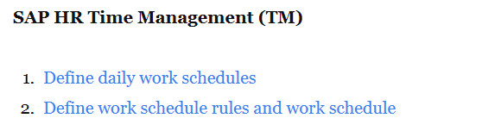

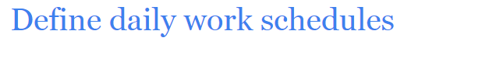

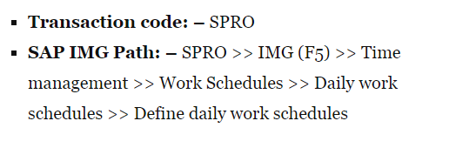

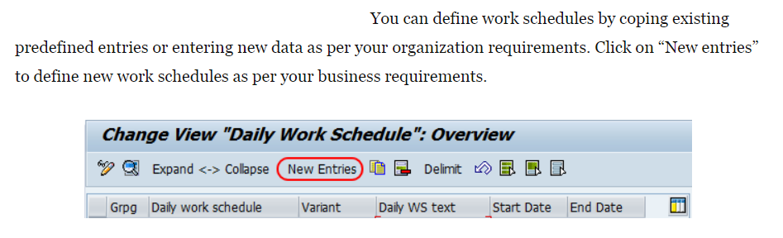

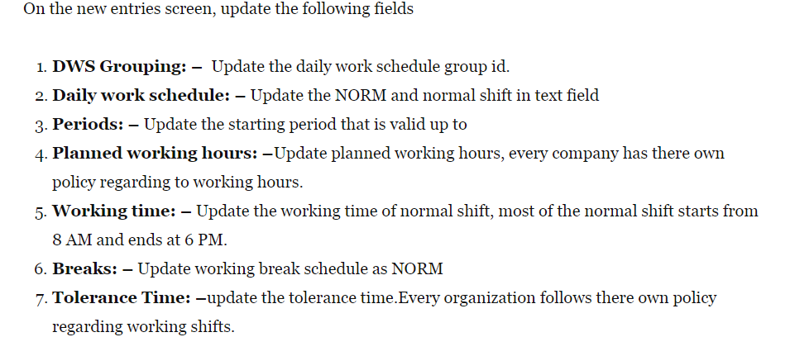

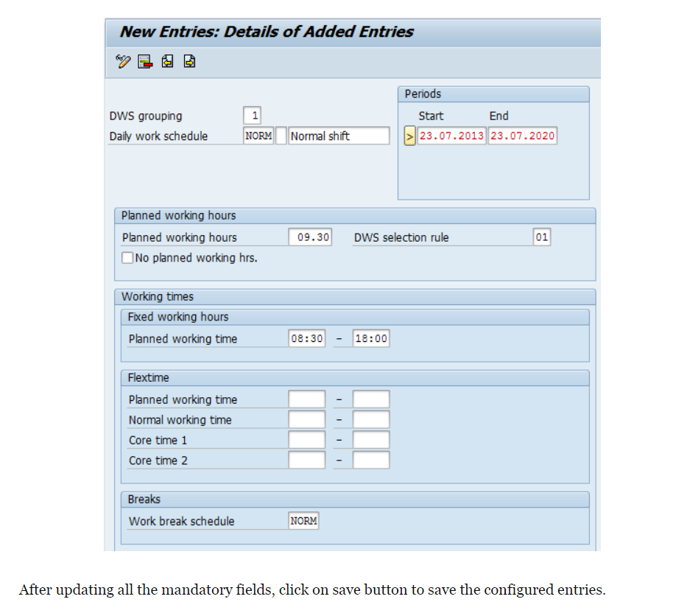

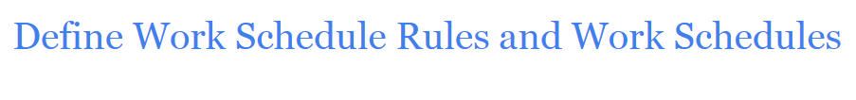

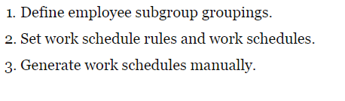

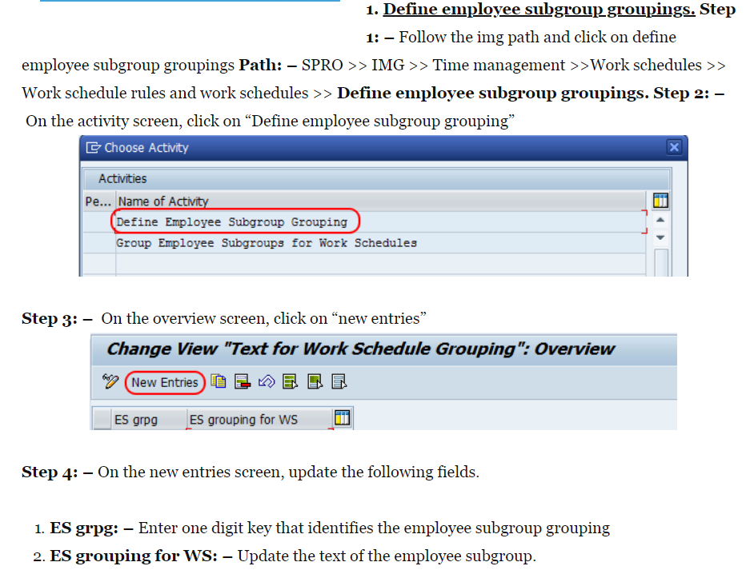

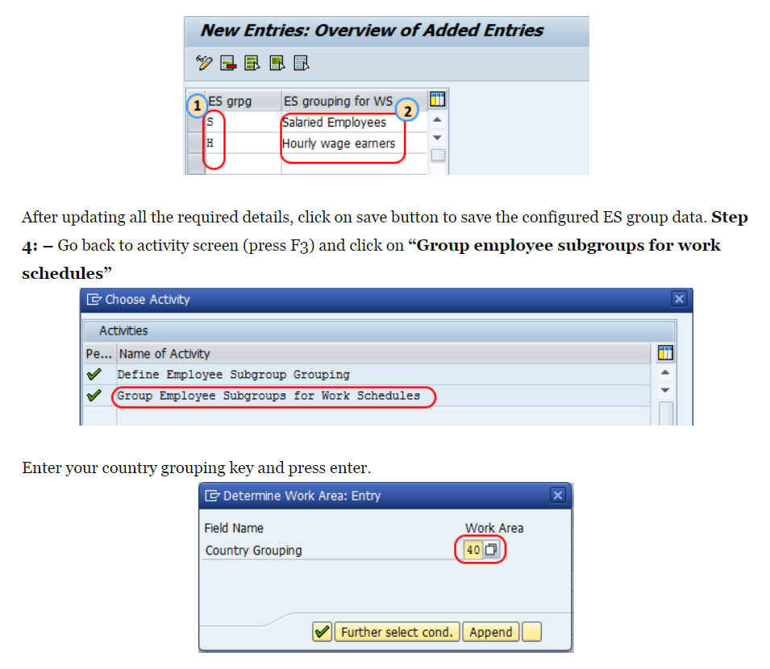

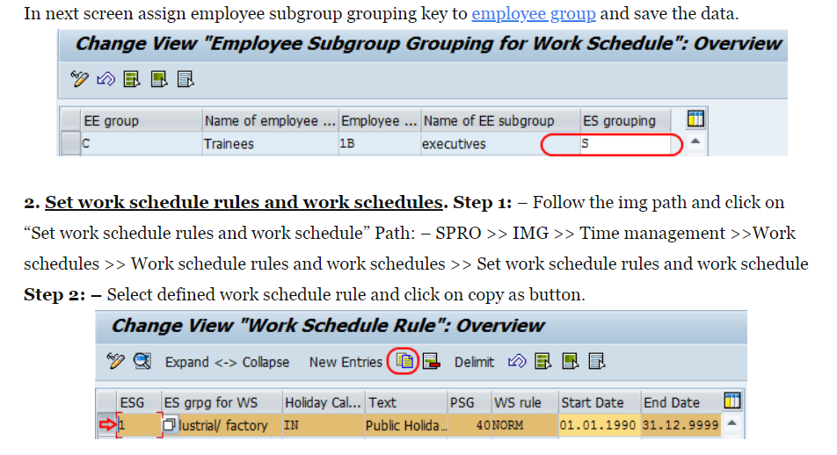

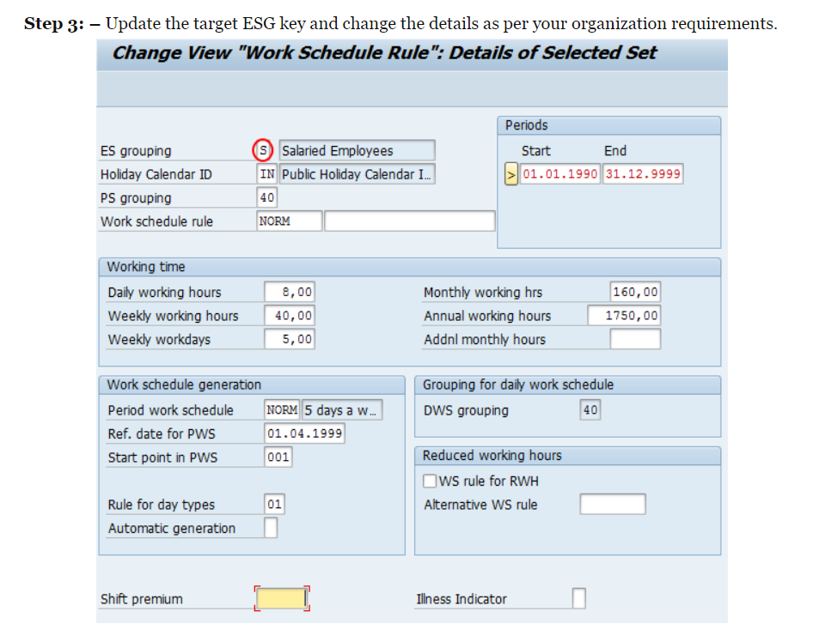

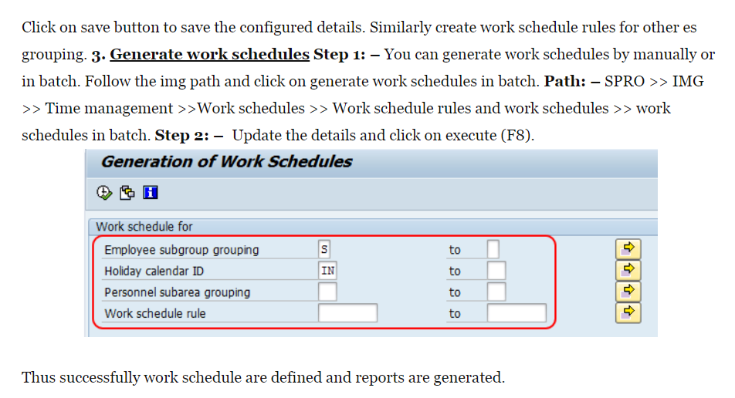

**SAP HR Time Management: PA51, PA53, PA61, PA62, PA63**

## ****SAP HR Time Data includes:****

* Daily working hours
* Absences (annual leave, sick leave, long service leave, etc.)
* Time-related payments (overtime, meal allowances, shift allowances, etc.)
* Absence quotas (accumulations, deductions, and corrections)
* Absence quota compensation for unused absence quota balances

## ****Time Types****

* Time data (attendances or absences) is stored using time types.
* Time types are stored in HR Master Data or created by the Time Evaluation program during time evaluation.  They have a 4-digit code assigned to them.
* For example: Time-related Payments = Time type 2000 to 2499, Absences = Time type 2500 to 2999

## ****Time Data Recording****

To record employee times in SAP  R/3 Time Management, such as hours worked, business trips, leave, or substitutions, you can use a variety of systems and methods, such as:

* Online by time administrators
* Separate time recording systems
* Cross-Application Time Sheet (CATS)
* Employee Self-Service (ESS) applications, such as Internet Application Components (IACs), Workflow forms, or touch screen systems
* Customer(Legacy) systems with an interface to the R/3 System

## ****Categories of Absences & Attendances****

There are 2 categories of absences :

1. Quota-driven absences
2. Non quota-driven absences

**Quota-driven absences**are absences with **allocated limits over a set period**(such as annual leave).

* These absences need to be recorded for legal and/or financial reasons.
* Entitlement can **be given at the start of the period**(e.g. as a total sum for the year), or can **be given gradually**with the total period being broken up into several smaller portions (as an accrual, e.g. monthly, depending on local practices and regulations).
* During the period of validity, **deductions can be made to the entitlement balance**(which could hold a negative value).
* Entitlement balances can be added from one year to the next or replaced by a new value each year.

**Non quota-driven absences**are absences that **do not have periodic limits**(such as study leave, bereavement leave and unpaid leave).

## ****Some important Time Management infotypes:****

|  |  |
| --- | --- |
| Absences | 2001 |
| Attendance | 2002 |
| Overtime | 2005 |
| Absence Quotas | 2006 |
| Attendance Quotas | 2007 |
| Time Events | 2011 |

## ****Important Time Transactions****

* **PA51**: Display time data
* **PA53**: Display time data
* **PA61**: Maint. Time data
* **PA62**: List entry for  additional data
* **PA63**: Maint. time data PA64: Calendar entry

# How to Run Time Evaluation: SAP PT60

Time Evaluation processes the employees' attendance at work and absences from work to make sure they are paid accordingly.

* It evaluates the employee's actual working time and absences.
* It calculates time-related payments.
* It updates absences quotas.
* It generates time wagetypes which are transferred to the Payroll Program.

Before executing the Payroll Program, all employees need to be processed successfully by the Time Evaluation Program.But time evaluation needs to run for relevant employees. Some employee populations may not have time evaluation requirements.

[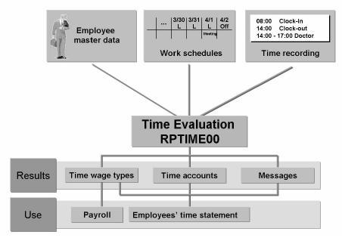](https://cdn.guru99.com/images/sap/2010/10/SAP-Time-Management.jpg)

**Step 1)** To Run Time Evaluation, Enter PT60 in the SAP Transaction Code Box

[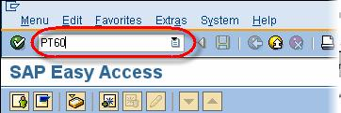](https://cdn.guru99.com/images/sap/2010/10/SAP-Time-Evaluation.jpg)

**Step 2)** In the next SAP Screen

1. Enter Personnel Number
2. Enter Evaluation Schema
3. Enter Evaluation Up to Date (The date until which Time Data will be evaluated)

**Step 3)** Enter any other selection field if required. Click Execute

[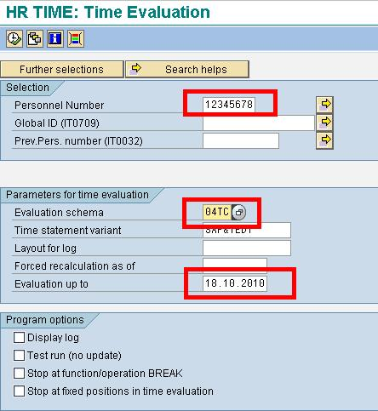](https://cdn.guru99.com/images/sap/2010/10/SAP-Time-Evaluation1.jpg)

**Step 4)** Time should be evaluated and a log must be displayed.

[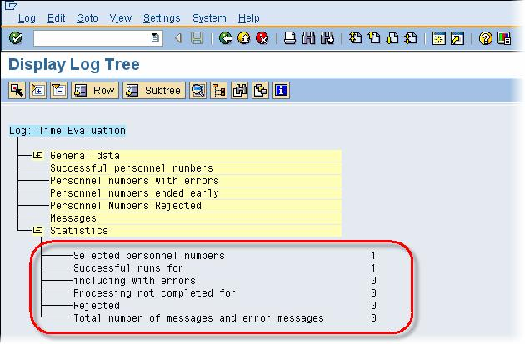](https://cdn.guru99.com/images/sap/2010/10/SAP-Time-Evaluation2.jpg)

You can view the Time Results Generated , using transaction **PT66**

# SAP PT66: How to Check Time Evaluation Results RPTIME

[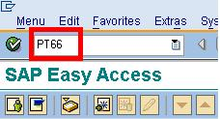](https://cdn.guru99.com/images/sap/2010/10/SAP-Time-Evaluation3.jpg)

**Step 2)** In the next SAP screen, Enter Personnel Number whose results you want to see 

[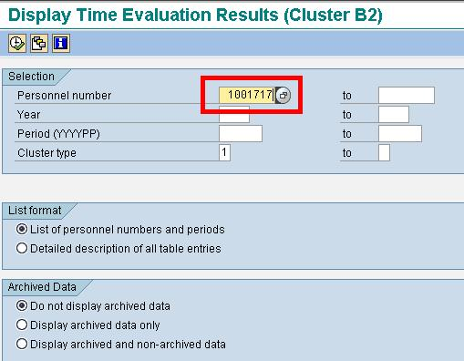](https://cdn.guru99.com/images/sap/2010/10/SAP-Time-Results.jpg)

**Step 3)** In the next SAP screen , double click on the period you want to see the results for.

[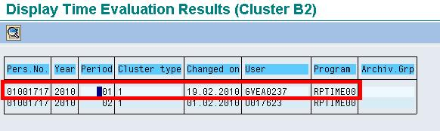](https://cdn.guru99.com/images/sap/2010/10/SAP-Time-Results1.jpg)

**Step 4)** In the next SAP screen, double click on the Table whose results you want to see

[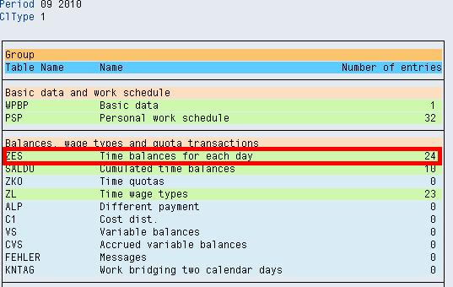](https://cdn.guru99.com/images/sap/2010/10/SAP-Time-Results2.jpg)

Results are shown-

[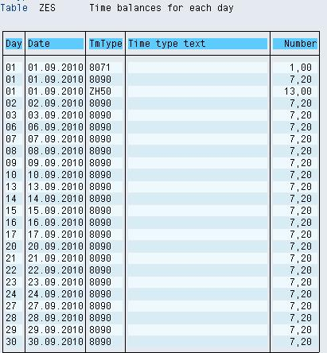](https://cdn.guru99.com/images/sap/2010/10/SAP-Time-Results3.jpg)